Draft Report by the Codex Secretariat on preliminary findings of Regular review of Codex work management: Cooperation between the Codex Alimentarius Commission and other standard-setting organizations

1. Introduction
The Codex Alimentarius Commission, at its 39th session, in 2016 (CAC39), agreed to discontinue discussion on the terms of reference of an internal Secretariat-led review of Codex work management practices and the functioning of the Executive Committee. However, the Commission requested that the Codex Secretariat regularly review work management as part of its monitoring of the Codex Strategic Plan 2014 –2019. The first regular review focused on electronic working groups.
The Codex Secretariat informed the Executive Committee at its 74th session (CCEXEX74) that the second regular review process would focus on cooperation with other international standard-setting organizations. Based on the Codex Strategic Plan 2014—2019, the scope of the review was to assess the status of current collaboration between Codex and governmental as well nongovernmental standard-setting organizations holding observer status and to formulate recommendations that would strengthen collaboration, identify good practices and possible synergies.
The review did not include cooperation with the World Organisation for Animal Health (OIE) and International Plan Protection Convention (IPPC). Codex has special relations with OIE and IPPC under the WTO Agreement on Sanitary and Phytosanitary Measures (WTO-SPS Agreement) and discussions in the Codex Committee on General Principles (CCGP) on collaboration between Codex and OIE concluded only recently.
The present report presents a summary of the preliminary findings of the review for feedback from members and observers, including those included in the review, which will inform the final report.

2. Request for feedback
Codex members and observers are invited to provide feedback by submitting comments containing substantial factual additions or objections to any of the findings and propose any recommendations for enhancing CAC’s cooperation with other standard-setting organizations.

3. Background
Monitoring and reporting by the Secretariat on relations with other international organizations (including other standard-setting organizations) had until the present review been restricted to recording an inventory of events and meetings attended, with no systematic gathering of further detail on potential synergies between Codex and other standard-setting organizations.
The subject for the 2017 review was selected to address this gap and follow up on activity 1.3.2 of the Strategic Plan. Moreover, the Secretariat expected that a closer review of the work management practices of other standard-setting organizations may inform its own work planning and management and thus contribute to Strategic Goal 4 “implement effective and efficient work management practices”.

4. Methodology
4.1 Timing
The Secretariat conducted the review between September 2017 and February 2018.
4.2 Selection of organizations
To ensure a detailed analysis of cooperation with and the work management practices of other international standard-setting organizations, a sample of 18 organizations with observer status in Codex was selected based on the following criteria:
- the organization’s mandate or main activities include the development of international standards or methods;
- the organization participates in the Inter-Agency Meeting on Methods of Analysis; or
- the organization is a standardization body referenced in specific trade concerns under the WTO Agreement on Technical Barriers to Trade (TBT Agreement).
The detailed list of selected organizations is contained in Appendix I. Table 1 below provides a brief overview, which was submitted to the Executive Committee for comments in October 2017.

Table 1: Organizations selected for review by observer type
International Intergovernmental Organizations | Non-Governmental Organizations
- African Organization for Standardization (ARSO)  - Bureau International des Poids et Mesures (BIPM)  - International Olive Oil Council (IOC)  - Organisation for Economic Co-operation and Development (OECD)  - Organisation Internationale de la Vigne et du Vin (OIV)  - Organisation Internationale de Métrologie Légale (OIML)  - Gulf Cooperation Council Standardization Organization (GSO)  - United Nations Economic Commission for Europe (UNECE) | - American Association of Cereal Chemists International (AACCI)  - American Oil Chemists Society (AOCS)*  - AOAC International  - Association of European Coeliac Societies (AOECS)  - International Accreditation Forum (IAF)  - International Federation of Organic Agriculture Movements (IFOAM)  - International Organization for Standardization (ISO)  - International Union of Pure and Applied Chemistry (IUPAC)*  - Nordic Committee on Food Analysis (NMKL)  - United States Pharmacopeial Convention (USP)
* Excluded due to lack of data.
4.3 Tools used to collect information
4.3.1 Desk research
The research covered general information about the selected organizations available from Codex working documents, Codex committee reports and the organizations’ websites.
4.3.2 Survey
A survey was transmitted to the 18 organizations in November 2017 (16 replied). The question were structured around the following clusters:
- general information;
- membership;
- capacity;
- work modalities;
- information exchange and participation in Codex activities; and
- future cooperation.
Appendix II contains some of the data resulting from the survey replies listed in order of findings.
4.3.3 Interviews
Six organizations were interviewed in face-to-face meetings, ten organizations were interviewed either via video or telephone conference call. The list of people interviewed in contained in Appendix III.

5. Review findings
This section presents the findings of the review by drawing out common themes based on the detailed information gathered as described in section 4.
5.1 General
Overall, Codex cooperation with standard-setting organizations was seen as not systematic, largely relying on the initiative of other organizations to invite Codex representatives to relevant meetings, identify relevant Codex standard-setting processes and provide input to those processes where necessary.

5.2 Membership
Compared to other standard-setting organizations with members comprising national governmental or government-affiliated bodies, the Codex Alimentarius Commission had the largest membership (188), followed by ISO (162). Over 20 percent of ISO member bodies, mainly from Africa and the Caribbean, also served as national Codex Contact Point (CCP) and were therefore familiar with the standard-setting processes of both organizations. The overlap between CCPs and the country contact points (where applicable) among the remaining organizations lay between zero and seven percent.

5.3 Capacity
5.3.1 Capacity for cooperating with Codex
The organizations reviewed had varying capacity to deal with Codex matters. While the majority (62 percent) had either at least one person dedicated to Codex matters, others had no specific contact point or were in the process of identifying one. More than half (63 percent) of the intergovernmental standard-setting organizations identified the absence of a single contact point for them (or observers in general) within the Codex Secretariat as a challenge. These organizations further expressed their wish to receive information on Codex activities in a timely manner better tailored to their needs.
5.3.2 Capacity building offered to own members
In terms of capacity-building activities offered to members, the organizations reviewed most frequently (50 percent) reported training courses, workshops and seminars. Other activities included: technical capacity-building or cooperation projects/programmes; discounts on fees or free access to certain products and services; the integration of training and education sessions into annual meetings; and financial support for the participation of developing countries.

5.4 Work Modalities
5.4.1 Languages
Most organizations reviewed had two official languages, 94 percent including English and 44 percent French. None of the organizations reviewed covered all six United Nations official languages and only one quarter listed more than two official languages.
5.4.2 Initiation of standard-setting process
Half of the organizations reported that non-members (e.g. private-sector companies, networks, associations), in addition to organizational members, were permitted to initiate a new development process. Four organizations noted that, unlike in Codex, staff members of the Secretariat were empowered to initiate the process of developing new standard or method.
5.4.3 Duration of standards development
All organizations that have developed more than one or two standard(s) or method(s) reported an average duration of the development process between one and three years—significantly shorter than the average of four years required in Codex. Two organizations identified the slow pace of the standard-setting process in Codex as among the major challenges to collaboration. They also highlighted their own transition over time from a rigid step procedure to a less formal, needs-based standard-setting process, which had helped increase overall speed and efficiency.
5.4.4 Standards development process
More than half of the organizations used online meeting systems (e.g. WebEx, Skype) and online knowledge-management systems or “member intranets” (e.g. Sharepoint, Grouploop, Clearspace) in their standard-development process. Unlike Codex, over 80 percent of the organizations reviewed also made systematic use of an online balloting system in their development processes.
5.4.5 Codex involvement in standards development
While the Codex Alimentarius Commission holds observer or liaison status in several organizations, allowing it to receive meeting documents and invitations, Codex representatives had been involved in the standard/method-development processes of only four of the organizations reviewed. Organizations in whose standard-setting process Codex was not involved would welcome the participation of Codex representatives in any relevant future meetings.
5.4.6 Review of standards
Half of the organizations had a process in place for the periodic review of their standards/methods, at intervals ranging between three (e.g. IFOAM), five (e.g. ARSO, ISO) and ten years (e.g. NMKL). While the other organizations also performed reviews, decisions to initiate them were based on needs identified and communicated by their membership or external stakeholders or on significant economic developments (e.g. increased international trade in a particular commodity).
5.5 Use of information and communication technology (ICT)
While several organizations had recently stepped up their use of ICT, they continued to prefer physical over virtual meetings early in the standard/method-development process or in cases where consensus was elusive. All organizations used their own websites to publish their standards/methods, while only one in four issued printed hard copies in addition. Additional ICT tools used for publication were email (31 percent), websites of members or stakeholders (13 percent) and social media (19 percent).
5.6 Monitoring the use of standards/methods
Most organizations (75 percent) monitored, or recently began monitoring, to some extent the use of the standards/methods they developed. However, the level of detail of such monitoring varied greatly and none of the organizations regularly published information on the adoption of their standards/methods to the general public. In most cases, the monitoring was carried out for internal purposes. IGOs tended to rely on information communicated by their member governments via questionnaires or notification of legislation referencing a specific standard. NGOs tended to monitor the use of standards/methods through download monitoring, sales, where applicable, and anecdotal evidence from the private sector.

5.7 Information exchange and participation in Codex activities
5.7.1 Codex meetings
Most organizations (75 percent) regularly attended sessions of at least one Codex committee and half had also attended at least one annual session of the Commission during the past four years. They normally provided updates on their activities or organizational changes on such occasions. With the exception of GSO, none of the reviewed organizations participated in FAO/WHO regional coordinating committee meetings.
5.7.2 Electronic Working Groups (EWGs)
Following attending committee meetings, participating in EWGs constituted the main form in which the organizations reviewed participated in Codex standard-setting activities. Out of those organizations having participated in EWGs (63 percent), two found the Codex EWG platform difficult to navigate and encouraged the Codex Secretariat to enhance its user-friendliness.
5.7.3 Other Channels
Around half of the organizations reviewed reported practices of submitting working documents or comments to Codex texts. Only a small number of organizations had participated in physical working groups (31 percent) or Codex workshops, webinars or other type of events (13 percent).
5.7.4 Mutual References
Most organizations (75 percent) made reference to Codex standards in their own standards, methods or guidance documents, while Codex only referenced those organizations (44 percent of those reviewed) that developed certain methods of analysis and sampling. Approximately 60 percent of organizations mentioned collaboration with Codex on their respective websites.

5.8 Future Collaboration
5.8.1 Drivers and Opportunities for Collaboration
Almost half of the organizations (44 percent) viewed participation in Codex meetings and events as the primary opportunity for collaboration. In particular, method-development organizations attached significant value to the work of the Codex Committee on Methods of Analysis and Sampling (CCMAS) and the Inter-Agency Meeting (IAM) held prior to CCMAS sessions. Several method-development organizations saw the IAM as a main driver for participation in Codex work. Several organizations (31 percent) collaborated with Codex in order to connect to a wider stakeholder group and raise awareness on topics they worked on. One in four identified a specific subject or Codex standards as the main opportunity for cooperation (e.g. measurement uncertainty, Codex standards on meat, revision of Hazard Analysis and Critical Control Point guidelines, third party conformity assessment).
5.8.2 Challenges
The challenges identified to collaboration with Codex varied significantly from organization to organization, with the same issue being identified as a challenge by more than two organizations in only few instances. These included: (i) the lack in Codex of a single contact point or facility for the provision of information tailored to organizations’ needs and interests (38 percent); (ii) a lack of resources to participate physically in all relevant Codex activities (31 percent); (iii) the Codex committee structure and complexity of interaction between committees (e.g. interaction between CCMAS and other general subject committees) (19 percent); and (iv) the limited role of observers in providing effective input to Codex standards (19 percent).
5.8.3 Suggestions
All organizations registered their interest in maintaining or enhancing collaboration with Codex. Method-development organizations were particularly interested in continuing the work on recommended methods of analysis and sampling (CCMAS STAN 234-1999) and formalizing the IAM. Some organizations, including those having had a higher level of interaction with Codex in the past (BIPM, OIML, UNECE), expressed interest in holding joint meetings at the Secretariat level to discuss future cooperation. Some organizations, including regional IGOs (ARSO, GSO), expressed interest in increasing their own capacity to participate and provide regional representation in Codex committee meetings and EWGs. Other valuable suggestions for future collaboration included: better liaison mechanisms at the levels of technical committees and national contact points; joint publications; continuation of reciprocal invitations to relevant events and meetings; and joint work on the Sustainable Development Goals and cross-cutting subjects like food adulteration.

APPENDIX I: Organizations selected for review
ORGANIZATION | CODEX OBSERVER STATUS | MISSION OR RELEVANT ACTIVITIES | WEBSITE
American Association of Cereal Chemists International (AACCI) | NGO | Relevant activity: Providing analytical methods and analytical proficiency programmes. | www.aaccnet.org
AOAC International | NGO | Mission: Advancing food safety and public health by bringing together members and organizations and convening worldwide experts from diverse interests dedicated to developing and validating standards, methods and technologies of global relevance. | www.aoac.org
American Oil Chemists' Society (AOCS) | NGO | Relevant activity: Developing methods of analysis used in global trade and research; conducting proficiency testing; providing reference materials; and coordinating with other standard-developers including ISO and the Codex Alimentarius. | www.aocs.org
Association of European Coeliac Societies (AOECS) | NGO | Relevant activity: Providing and maintaining the AOECS Standard providing guidance and technical requirements to producers and food-safety inspectors for the manufacture of gluten-free products. | www.aoecs.org
African Organization for Standardization (ARSO) | IGO | Mission: Facilitating intra-African and global trade by providing and facilitating the implementation of harmonized standards. | www.arso-oran.org
Bureau International des Poids et Mesures (BIPM) | IGO | Relevant activities: Coordinating international comparisons of national measurement standards agreed to be of the highest priority; and establishing and maintaining appropriate reference standards for use as the basis of key international comparisons at the highest level and providing selected calibrations therefrom. | www.bipm.org
Gulf Cooperation Council Standardization Organization(GSO) | IGO | Relevant activities: Formulating, adopting, updating and publishing technical regulations, Gulf standards, Gulf Conformity Assessment Procedures for commodities and products, measuring and calibration devices, definitions, symbols and technical terminology, and criteria for sampling, inspection, testing and calibration according to relevant implementing rules; and preparing draft Gulf technical regulations and standards according to the Organization's Directives of Technical Work. | www.gso.org.sa
International Accreditation Forum (IAF) | NGO | Relevant activity: Developing and/or recognizing appropriate processes and practices for the conduct of conformity assessment worldwide and ensuring their universal application by IAF Accreditation Body Members and their accredited certification, registration and/or inspection bodies. | www.iaf.nu
International Federation of Organic Agriculture Movements (IFOAM) | NGO | Relevant activity: Advocating and providing competence for the creation of a favourable policy environment, including the development and endorsement of organic standards. | www.ifoam.bio
International Olive Oil Council (IOC) | IGO | Relevant activity: Encouraging the expansion of international trade in olive oil and table olives, drawing up and updating product trade standards and improving quality. | www.internationaloliveoil.org
International Organization for Standardization (ISO) | NGO | Mission: Promoting the development of standardization and related activities in the world with a view to facilitating international exchange of goods and services and to developing cooperation in the spheres of intellectual, scientific, technological and economic activity. | www.iso.org
International Union of Pure and Applied Chemistry (IUPAC) | NGO | Relevant activity: Providing terminology, including naming new elements in the periodic table, standardized methods for measurement, atomic weights and many other critically evaluated data. | www.iupac.org
Nordic Committee on Food Analysis (NMKL) | NGO | Relevant activity: Providing reliable methods for foods and feeds. | www.nmkl.org
Organisation for Economic Cooperation and Development (OECD) | IGO | Relevant activity: Setting a wide range of international standards, covering topics, from agriculture and tax to the safety of chemicals. | www.oecd.org
Organisation internationale de métrologie légale (OIML) | IGO | Relevant activity: Developing model regulations, standards and related documents for use by legal metrology authorities and industry. | www.oiml.org
Organisation internationale de la vigne et du vin (OIV) | IGO | Mission: Contributing to the international harmonization of existing practices and standards and, as necessary, to the preparation of new international standards in order to improve the conditions for producing and marketing vine and wine products, and to help ensure that the interests of consumers are taken into account. | www.oiv.int
United Nations Economic Commission for Europe (UNECE) | UN | Relevant activities: Facilitating greater economic integration and cooperation among its member countries and promoting sustainable development and economic prosperity through: policy dialogue, negotiation of international legal instruments, development of regulations and norms, exchange and application of best practices as well as economic and technical expertise, and technical cooperation for countries with economies in transition. | www.unece.org
United States Pharmacopeial Convention (USP) | NGO | Mission: Improving global health through public standards and related programmes that help ensure the quality, safety and benefit of medicines and foods. | www.usp.org

APPENDIX II: Background data
Finding 5.2: Membership
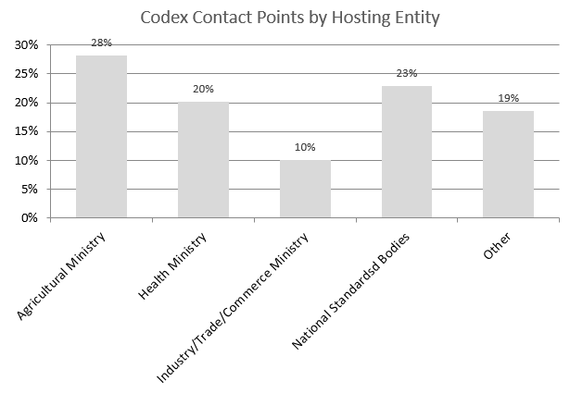
Codex |  | ISO | OIML | BIPM | UNECE | OIV | IOC | OECD | ARSO | GSO
# of Member countries* | 187 | 162 | 62 | 58 | 56 | 46 | 42 | 35 | 36 | 7
% of national contacts same as Codex Contact Points | / | 22 | 1 | 0 | na | 7 | na | na | 7 | 3
* as of September 2017
Finding 5.3.1: Capacity for cooperating with Codex
 | AACCI | AOAC | AOECS | ARSO | BIPM | UNECE | GSO | IAF | IFOAM | IOC | ISO | NMKL | OECD | OIML | OIV | USP
Dedicated staff for Codex matters* | no | 1 | 2 | 1 | 1 | no | 2 | no | no | unit | 1 | 1 | Units | no | no | unit
* no means no dedicated person working Codex matters, but a liaison contact exists
Finding 5.3.2: Capacity building offered to own members
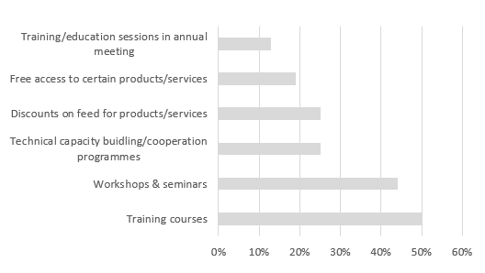
Finding 5.4.1: Languages
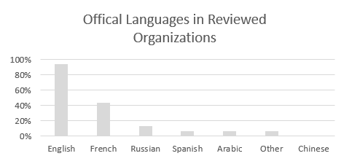
Finding 5.4.3: Duration of standards development
 | AACCI | AOAC | AOECS | ARSO | BIPM | UNECE | GSO | IAF | IFOAM | IOC | ISO | NMKL | OECD | OIML | OIV | USP
average duration in years | na | 1 | na | 2 | na | 3 | 1 | na | na | / | 2 | 3 | na | 3 | 3 | 3
Findings 5.7: Information exchange and participation in Codex activities
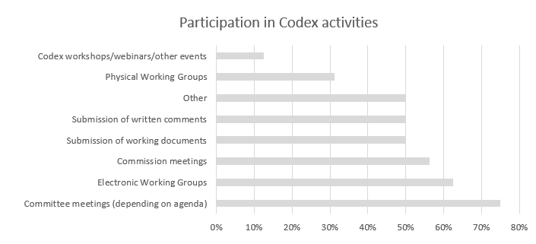
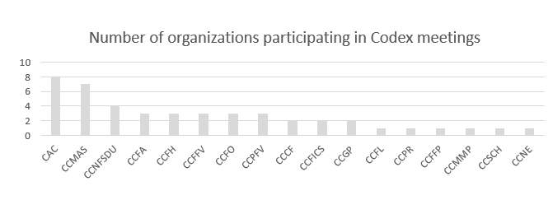
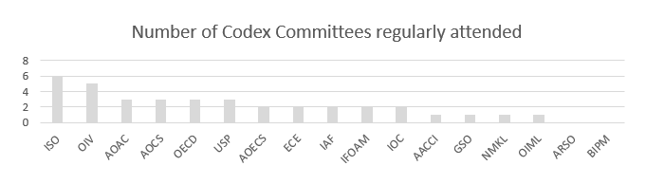
Finding 5.7.4: Mutual references
 | AACCI | AOAC | AOECS | ARSO | BIPM | UNECE | GSO | IAF | IFOAM | IOC | ISO | NMKL | OECD | OIML | OIV | USP
Organization makes reference to Codex texts in own standards/methods | X | X | X | X |  | X | X |  | X | X | X | X | X |  | X

APPENDIX III: List of persons interviewed
NAME | ORGANIZATION | TITLE
Anne Bridges | American Association of Cereal Chemists International (AACCI) | Approved Methods Technical Committee Chair
Darryl Sullivan | AOAC International | Director, Industry and Regulatory Affairs
Hertha Deutsch | Association of European Coeliac Societies (AOECS) | Codex Delegate and President of the Austrian Coeliac Society
Sarah Sleet | Association of European Coeliac Societies (AOECS) | Chair
Reuben Gisore | African Organization for Standardization (ARSO) | Technical Director
Robert Wielgosz | Bureau International des Poids et Mesures (BIPM) | Director of Chemistry Department
Ralf Josephs | Bureau International des Poids et Mesures (BIPM) | Principal Chemist
Nabil A Molla | Gulf Cooperation Council Standardization Organization(GSO) | Secretary General
Zaki M. Al-Rubaei | Gulf Cooperation Council Standardization Organization(GSO) | Head of Marketing & International Relations
Bader A. Al-Nassar | Gulf Cooperation Council Standardization Organization(GSO) | Head of Standards and Metrology
Abdullah Ibrahim Alhadlaq | Gulf Cooperation Council Standardization Organization(GSO) | Acting Head Technical Committees
Kylie Sheehan | International Accreditation Forum (IAF) | General Manager Operations, JAS-ANZ
Diane Bowen | International Federation of Organic Agriculture Movements (IFOAM) | Organic Policy and Guarantee Senior Advisor
Mercedes Fernández | International Olive Oil Council (IOC) | Head of the IOC Research and Standardisation Unit
Marie- Noëlle Bourquin | International Organization for Standardization (ISO) | Head, Agricultural Quality Standards Unit Economic Cooperation and Trade Division
Nina Skall Nielsen | Nordic Committee on Food Analysis (NMKL) | Secretary General
Magdalini Sachana | Organisation for Economic Cooperation and Development (OECD) | Policy Analyst
Ian Dunmill | Organisation internationale de métrologie légale (OIML) | Assistant Director
Jean-Marie Aurand | Organisation internationale de la vigne et du vin (OIV) | Director General
Yann Juban | Organisation internationale de la vigne et du vin (OIV) | Deputy Director General
Jean-Claude Ruf | Organisation internationale de la vigne et du vin (OIV) | Scientific Coordinator
Liliana Annovazzi-Jakab | United Nations Economic Commission for Europe (UNECE) | Head, Agricultural Quality Standards Unit
Jaap Venema | United States Pharmacopeial Convention (USP) | Chief Science Officer & Chair, Council of Experts
Kristie Laurvick | United States Pharmacopeial Convention (USP) | Senior Food Science Officer

Activity 1.3.2: Promote cooperation with other international governmental and non-governmental standard-setting organizations to support development of relevant Codex standards and to enhance awareness, understanding and use of Codex standards; Indicator: Current collaboration between international intergovernmental and non-governmental organizations reviewed and, where relevant, procedures updated.
REP14/GP, para. 44-75.
ARSO, BIPM, GSO, IOC, ISO, OECD, OIML, OIV and UNECE.
IOC, ISO, OIV and UNECE.
IOC, ISO, OECD and UNECE.

